Centers in Middle School

When to do centers
- Interacting
- Extending
- Outside the 3 moments of a lesson/independent work
- Review for assessments
- Whenever it works best for your classroom

How to manage centers
- Visuals
- Student groups
- Flipchart from Meridith

What to put in Centers
- Previously taught content in a new format
- Sort
- Sage and scribe
- Viewing with a focus
- Reading with a focus
- Labs from same big concept
- Project based learning

Resources
Learning Centers in the Secondary Classroom
Launching Learning Centers in Middle School

Math Stations in Middle Grades
Math Stations
Math in the Middle
Guided Math in the Upper Grades

Science Stations
Science Classroom Learning Centers
Middle School Science Stations
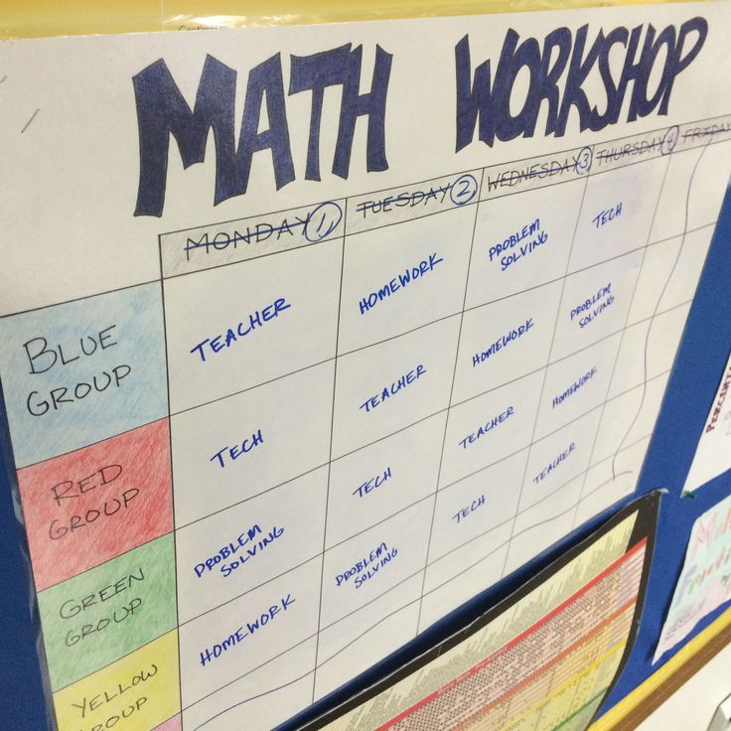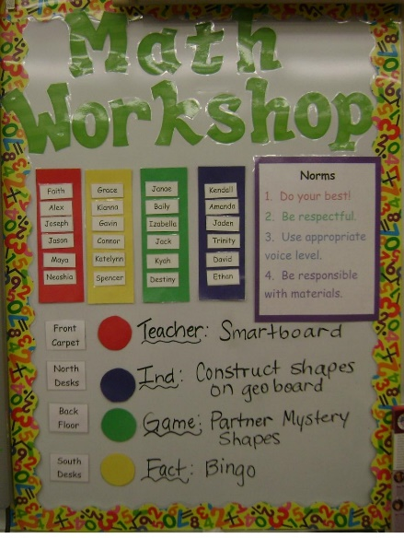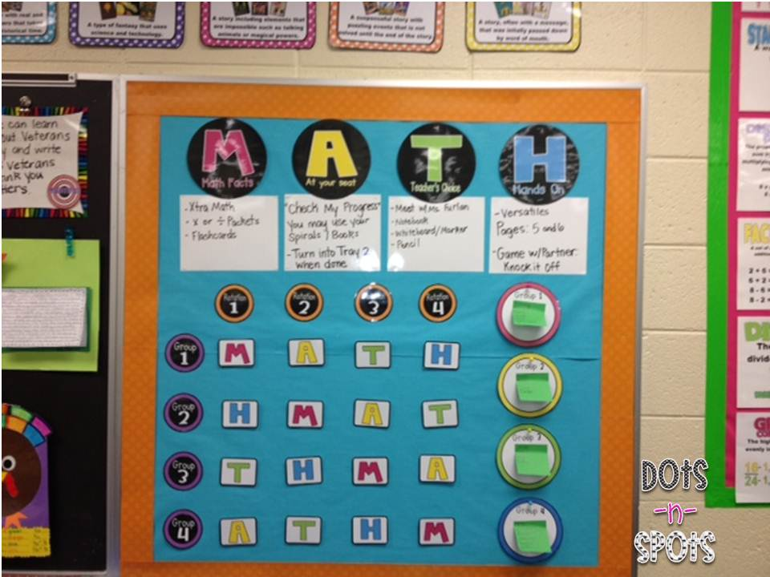

Center | Center | Center | Center | Teacher Table
1 | 2 | 3 | 4 | 5
2 | 3 | 4 | 5 | 1
3 | 4 | 5 | 1 | 2
4 | 5 | 1 | 2 | 3
5 | 1 | 2 | 3 | 4

Or
Group name | Monday | Tuesday | Wednesday | Thursday | Friday
Blue
Red
Green
Yellow
Orange?
With
 | Block 1 | Clock 2 | Block 3 | Block 4
Blue
Red
Green
Yellow
orange

